Jessica Fealy 18024092

Secure System report

Table of Contents
User Log in Credentials 2
Sensors 2
Data generation 3
Averaging 3
Complier flags 3
Complier warnings 4
Secure Coding Rules 4
Unsigned integers – wrapping protections 4
Signed integers 5
Secure file IO 7
Reading from a file 7
Writing to a file 8
Secure strings 8
Secure keyboard IO 9
String validation 10
Integer validation 10
Expecting a string 10
Expecting an integer as a keyboard IO 10
Secure menu options 11
Secure dynamic memory and pointers 11
Secure patterns 12
Authentication 12
Model Class View 12
Secure Logger 13
Interface 13
Displaying sensor data 13
All sensors taking readings and averages 13
Display and update sensors 14
Log interactions 14
Sensor log options 14
Viewing all logs 15
24 most recent 16
24 least recent 17
Device log 18
Device interactions 18
Thermometer interactions 19
Humidity interactions 19
Wind sensor interactions 19
All interactions 19
Persistent storage 20
UML Diagrams – Full diagram can be found in submission folder 21
Secure logger 21
Auth Pattern 22
Model View Controller 22

User Log in Credentials
ID | Password | Admin or User
0000 | ALUNKING1234 | Admin
0001 | JANUSZKULON1234 | Admin
0002 | ADMINADMIN1234 | Admin
0003 | USERUSER1234 | User

Sensors
This program uses 3 sensors that act as a weather station, the following sensors are used:
- Thermometer – “ Temp.cpp “ “temp.h”
  - This sensor has data randomly generated between -10 to 30 to simulate readings
  - The reading are interpreted as centigrade and converted to fahrenheit using overflow protections for additions, multiplication and divisions
  - This sensor uses a state to determine whether the sensor is on or off
- Humidity sensor – “Humidity.cpp” “Humidity.h”
  - This sensor has data randomly generated between 0 – 99 to simulate humidity data
  - The data is interpreted as a % and displayed as such
  - This sensor uses a state to determine whether or not the senor is on or off
- Wind sensor – “WindSensor.cpp” “WindSensor.h”
  - This sensor takes random readings between 0 – 69 to simulate wind speed data
  - The readings are interpreted as KPH but is converted to MPH for display, no protections are needed for this calculation as a mere division is required
  - This sensor can actuate, when the wind speed exceeds 60KPH the sensor will automatically actuate to a netural position, this is to protect the gear box from excessive damage in a storm front
  - The actuation can manually be performed by an Admin, this is incase the sensor becomes stuck in the netural position
  - This sensor also has a state to store whether the sensor is on or off
- Additional functionality
  - All sensors at the end of readings will have their averaged. This process is preformed securely by ensuring no wrapping or overflow

Data generation
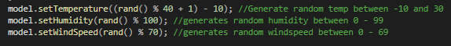

Averaging
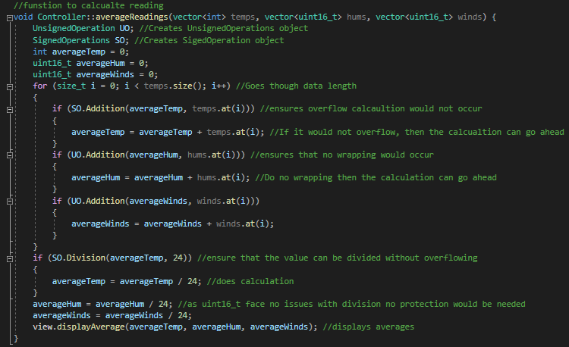

Complier flags
All required flags have been set, and all rules have been set. Complier warning persist from GSL libraries, but I can’t do anything to fix these. A screenshot of remaining complier warning can be found below
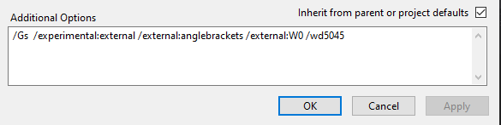
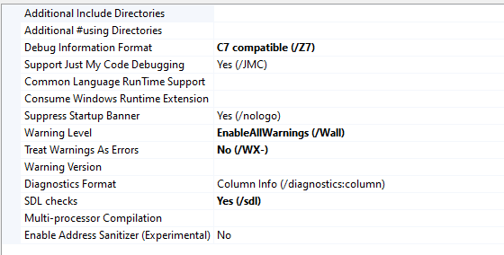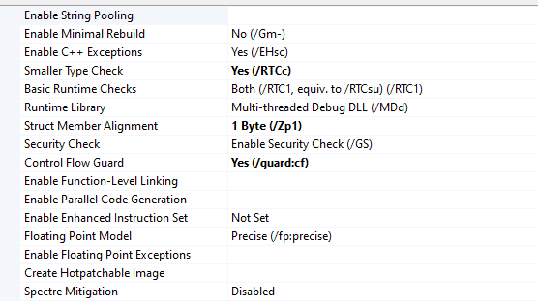

Complier warnings
With GSL related warning not filtered out
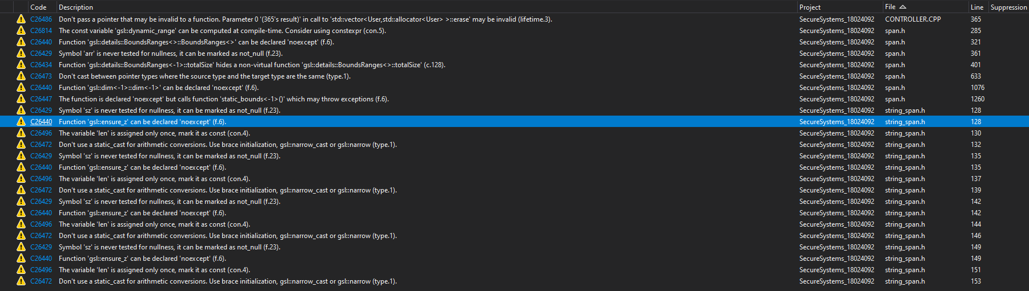With GSL related warnings filtered out

Secure Coding Rules

Unsigned integers – wrapping protections
The following methods have been used throughout the code to ensure that any instance of real-time calculations involving unsigned ints are fully protected from wrapping.
Uint16_t has been primarily been used to store the value of the wind speed, both in KPH and MPH. Uint16_t has also been used to store the value of humidity. As neither of this value can go below 0
This can be found “UnsingedOperations.cpp” “UnsingedOperations.h”
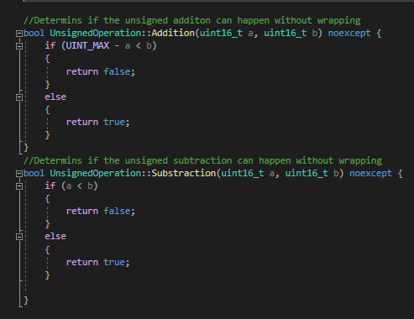
Use cases of unsinged int additions can be found below (Where UO is an object of an object of UnsignedOperations ) The following examples can be found in Controller.cpp under function averageReadings()
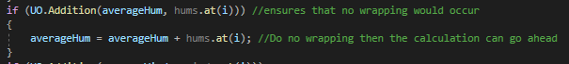
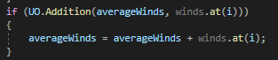

Signed integers
Signed integers have primarily been used to store the values of temperature, this is because temperature can be either negative or positive.
The following class is designed to checks all signed int calculations to ensure that no overflow would occur before the calculation occurred. This class can be found “SignedOperations.cpp” “SignedOperations.h”

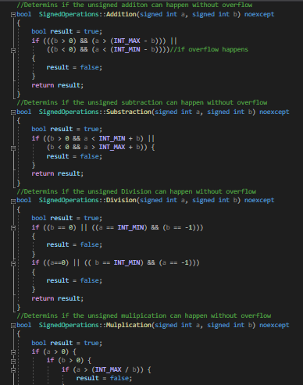
This class has been used in the following instances:
This can be found in “ temp.cpp “
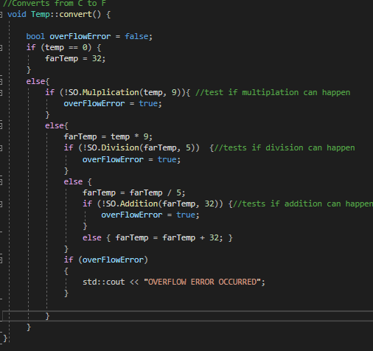
These can be found under “ Controller.cpp”
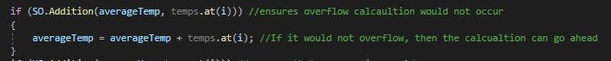
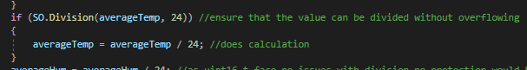

Secure file IO

Reading from a file
There are many instance that scure FILO IO can be found throughout my program, they all follow the same pattern. One example of secure reading from a file can be found below. The following cpp files contain secure file IO:
- Controller.cpp
- Model.cpp
- AuthenticatonInfo.cpp
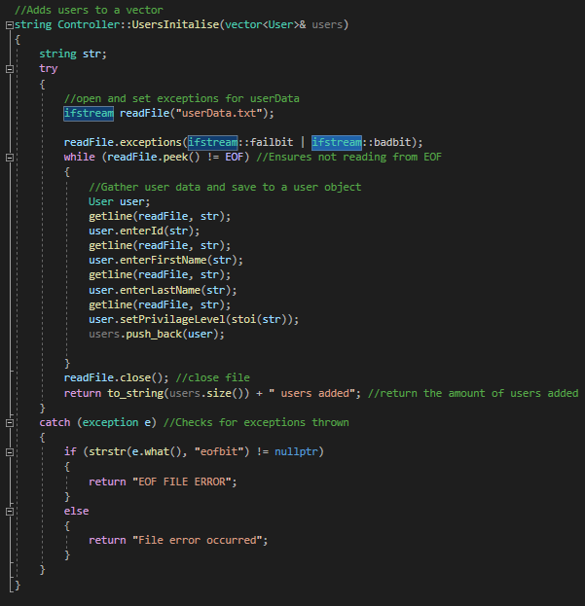

Writing to a file
Like reading from a file there are many instance of this happening though out my project, below is one example of this code. However further evidence can be found on the following cpp files:
- AuthenticationInfo.cpp
- Model.cpp
- FileLogger.cpp
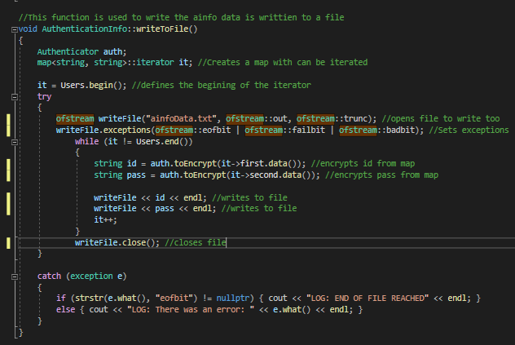

Secure strings
Initially used a char array with size 40 to take data from the users, using cin.width to ensure there were no overflow errors. Then checked the formatting of the data to ensure all data was letters. This was changed to intake a string and ensure that all chars were letters and that the size of the string was less than 40. 40 to ensure that this can be read from the file correctly.
This can be found on “ User.cpp “
The char pointer was also protected by ensuring that it wasn’t a null pointer
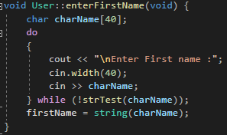
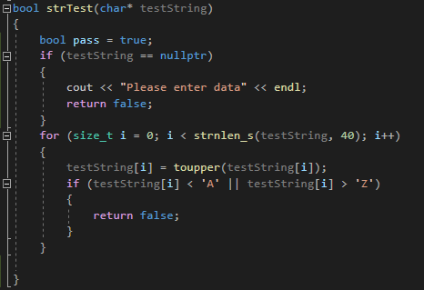
Updating to string

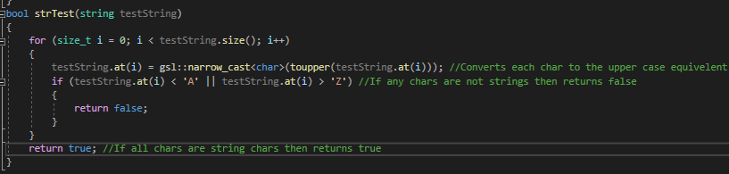
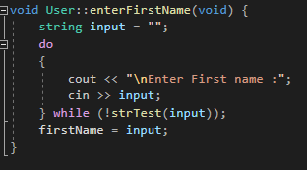
There are no character arrays throughout the code, and any instances of user input data or reading from a file is handled by taking input as a string then checking the contents are as expected, then converting to a usable data type.

Secure keyboard IO
All user input areas are taken in as a string to ensure that no buffer overflow can occur. When the input data is expected to be a string, this is data is sent through a function to scan each char to ensure that all chars are from the English alphabet.
When the input wanted is an integer, the data is taken as a string, then each char is scanned to ensure that all chars are numbers. When this is completed, the char value is tested to ensure it fits between the acceptable ranges for the program to ensure that there will be no conversion issues. If the input fulfils all this then the string is converted to an int for use.

String validation
Strings are validation in “User.cpp”

Integer validation
Integer validation can be found under “View.cpp” and “User.cpp”
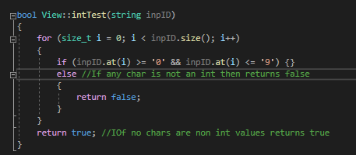

Expecting a string
This example can be found under “User.cpp”
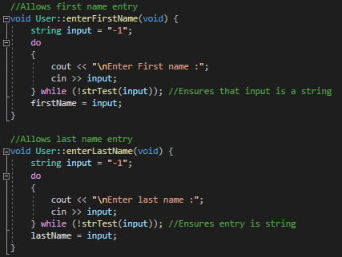

Expecting an integer as a keyboard IO
Many examples of this can be found throughout “User.cpp” and “View.cpp”
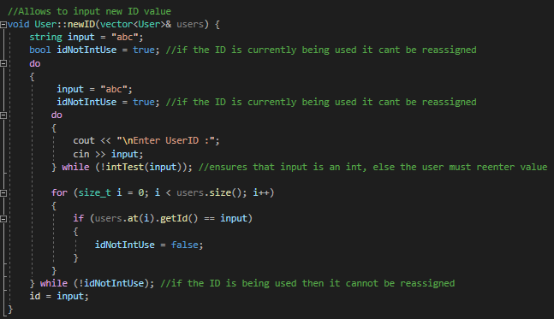

Secure menu options
Examples of this can be found under “View.cpp”
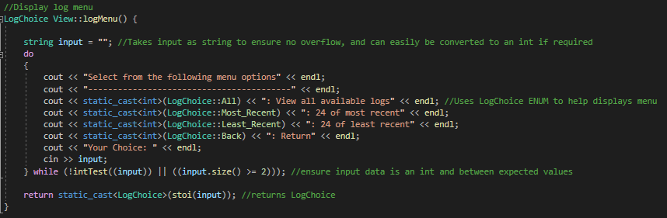

Secure dynamic memory and pointers
The primary use cases of dynamic memory and pointers are used without the logger system, this is achieved by using smart pointers. By using smart pointers ensure that all instances of the logger is secure and less prone to any exceptions being thrown, are self-destroying and are memory leak free.
The creation of the FileLogger can be found under “Model.h” by using const unique_ptr
The pointer is that defined in “ Model.cpp “
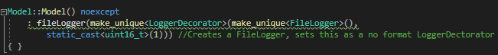
FileLogger is used in various places in Model.cpp
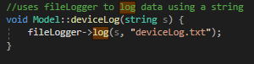

Secure patterns

Authentication
Using authentication pattern ensure that only registered user are able to log into the system as an admin or user. A proof of ID is assigned to the system and the user logged in, this is to ensure continuity of user when traversing throughout the program, the users proof of id and the systems proof of id is checked before accessing any secure sub systems.
This system supports multiple users with different privilege levels to be registered with the system, currently there is 4 users registered with the system, however additional users can easily added though device sub system, and users can be remove from the device. Only admins have such privileges
User credentials is persistently stored in “ainfo.txt” using XOR encryptions
The following files are responsible for authentication:
- User.h, User.cpp
- ProofID.h, ProofID.cpp
- Authenticator.h, Authenticator.cpp
- AuthenticationInfo.h, AuthenticationInfo.cpp

Model Class View
The MCV is the backbone of the program. Where this secure pattern handles the menu systems with Controller and View, to accessing and using the sensors with Controller and Model.
- Controller – “Controller.h” “Controller.cpp”
  - This class handles getting sensor data from Model to display to View
  - Adding and removing users by using authenticator object
  - Managing logging in via an authenticator object
  - Holds menus for controlling sensors
- Model – “Model.h” “Model.cpp”
  - Handles getters and setters from the sensors to the controller
  - Connects with logged to log both sensor and devices
  - Handles reading data from sensors and device logs
  - Communicates with sensors to control actuation and other states
- View – “View.h” “View.cpp”
  - Handles displaying menus to the console, communicating user responses to controller
  - Handles displaying sensor data
  - Handles displaying log data

Secure Logger
A secure logger has been implemented to log sensor data and device data to their respectively files. The logger utilises a “Logger Decorator” to correctly format the log data. The loggers are initialised and accessed using smart pointers (Seen below). The logger is only accessed from “Model.cpp”. The following files are responsible for the secure logger:
- BaseLogger.h, BaseLogger.cpp
- ConsoleLogger.h, ConsoleLogger.cpp
- FileLogger.h, FileLogger.cpp
- LoggerDecorator.h, LoggerDecorator.cpp
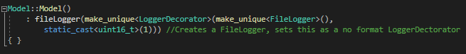

Interface

Displaying sensor data
When the sensors are being read from all their data is shows concurrently, including conversions and the wind sensors operating state. Sensors can also be taken manually under menu option “Display and update sensors “

All sensors taking readings and averages
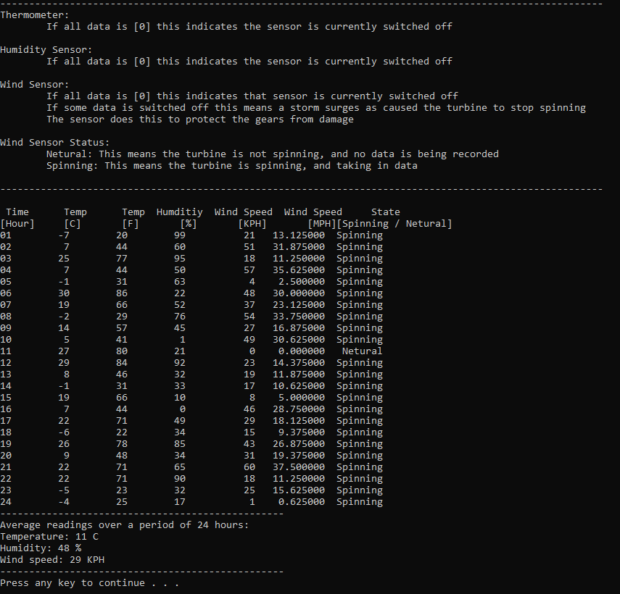

Display and update sensors
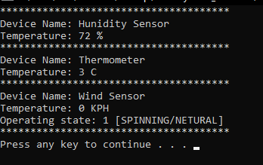

Log interactions
The user has the choice of seeing all sensor log data, 24 most recent log data, or 24 of the least recent log data. When it comes to device logs the user can only see all the data at one time. In the hour slot, if the data is configured with “ 99 “ this means that the sensor readings have been manually taken.

Sensor log options
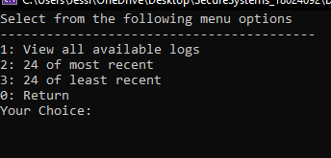

Viewing all logs
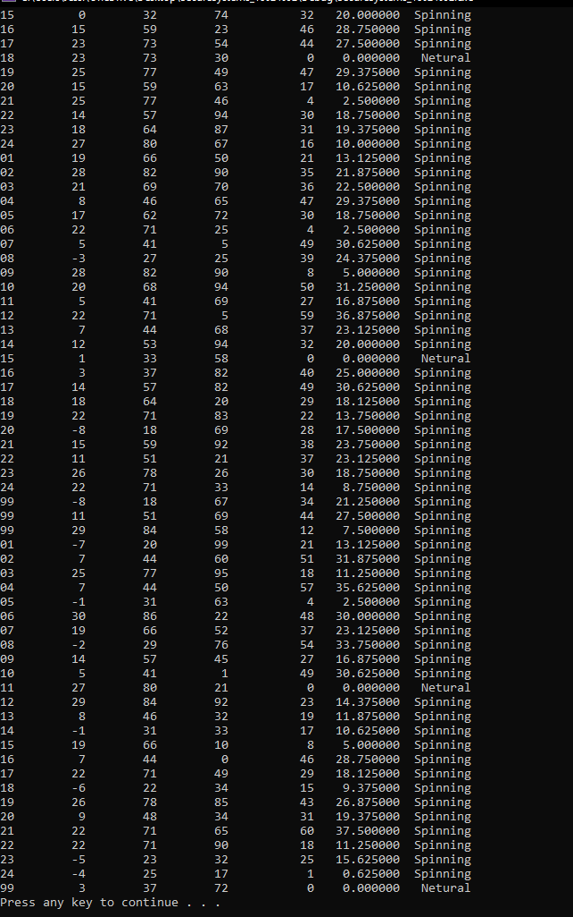

24 most recent
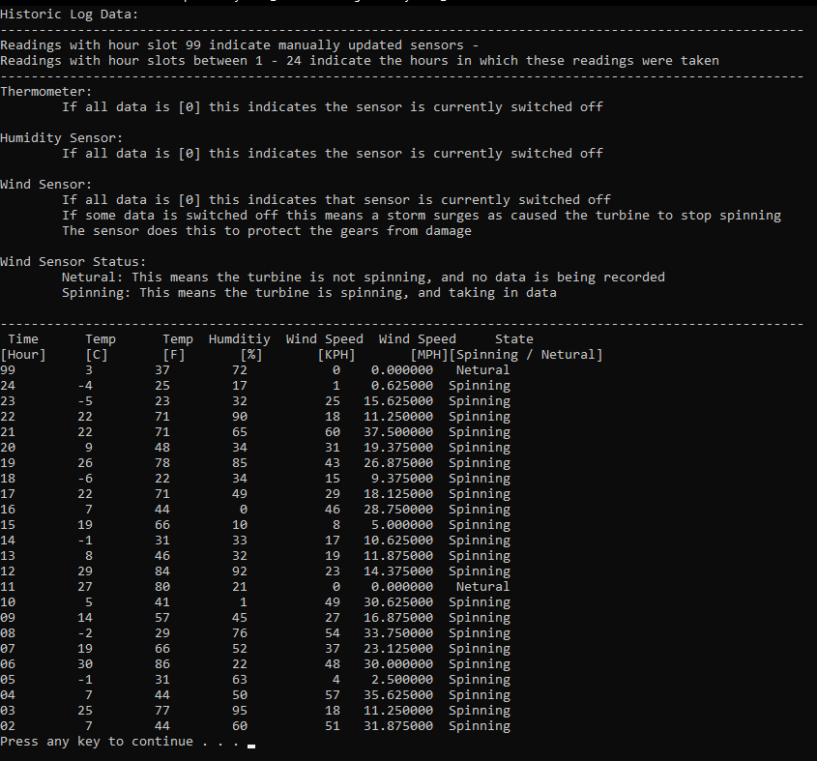

24 least recent
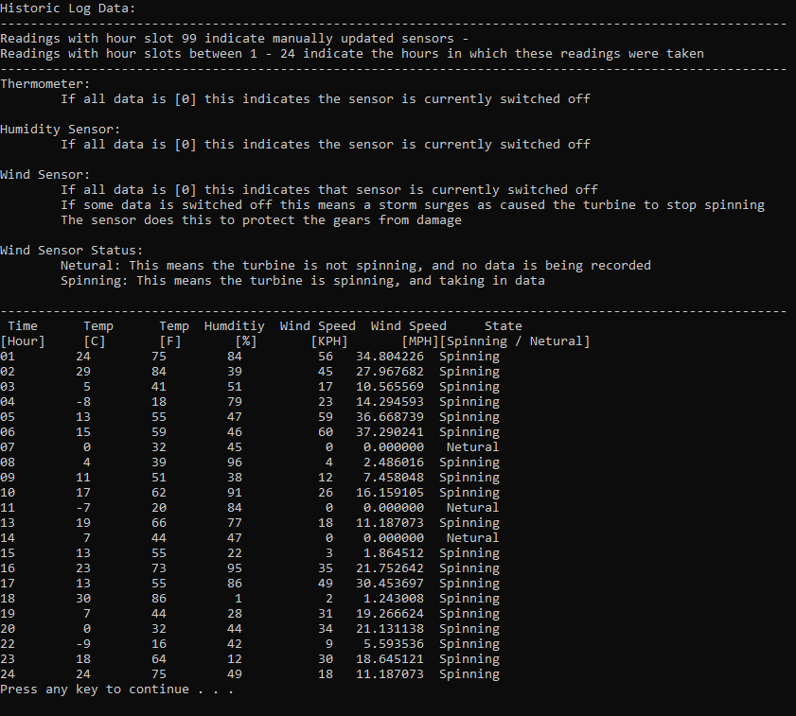

Device log

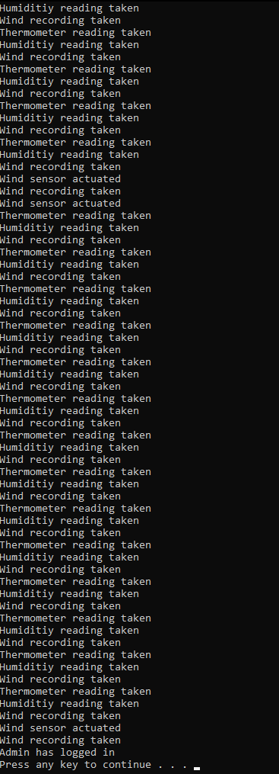

Device interactions
- Turning off all sensors individually or together
- Turning on all sensors individually or together
- Configuring all sensors individually or together
- Manually actuating wind sensor
- Reading data and averaging all sensors for a period of 24 hours
- Manually update all sensors

Thermometer interactions
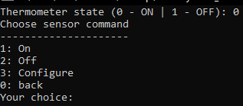

Humidity interactions
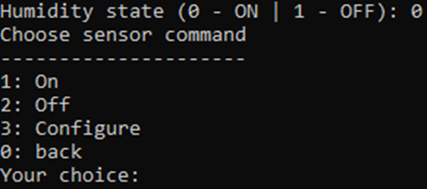

Wind sensor interactions
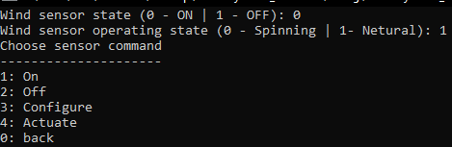

All interactions
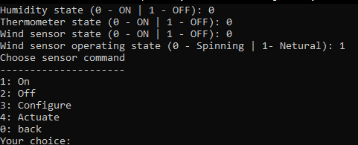

Persistent storage
Persistent storage has been used to store:
- Encrypted ID and Pass – used for logging in “ainfo.txt”
  - ID used to assign the user credentials to the user
  - When a new user have been added their details are also added to the ainfo.txt
  - When a user has been removed their details are removed from ainfo.txt
- User and admin details – used for having multiple users “userData.txt”
  - New users can be added – their details are added to userData.txt
  - User can be removed – Their details are removed from userData.txt
- Sensor logs – “historicData.txt”
  - Every sensor reading taken is added to this file
- Device logs - “deviceLog.txt”
  - Any state changes are added to this log
  - Any log ins is added to this log
  - Any added or removed user are added to this log
All data has been written too securely using sure FILE IO
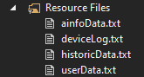

UML Diagrams – Full diagram can be found in submission folder

Secure logger
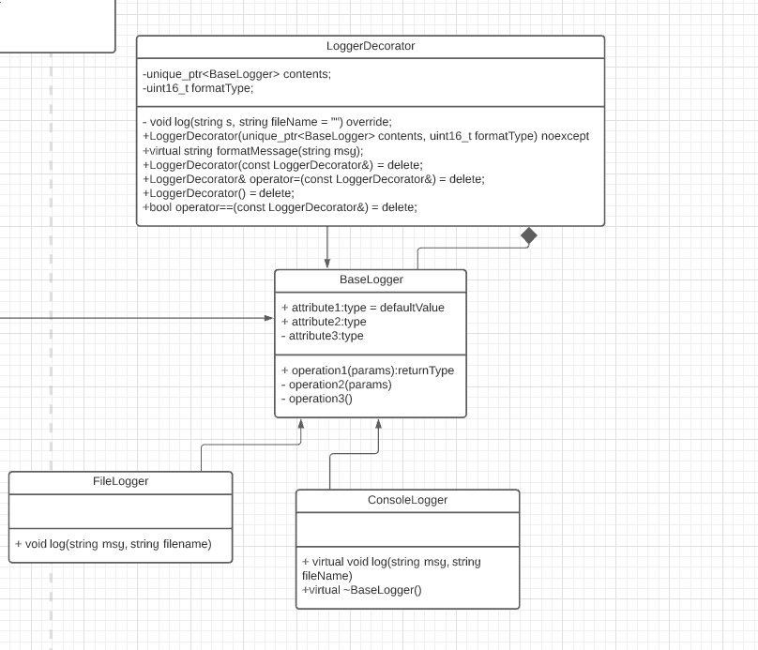

Auth Pattern
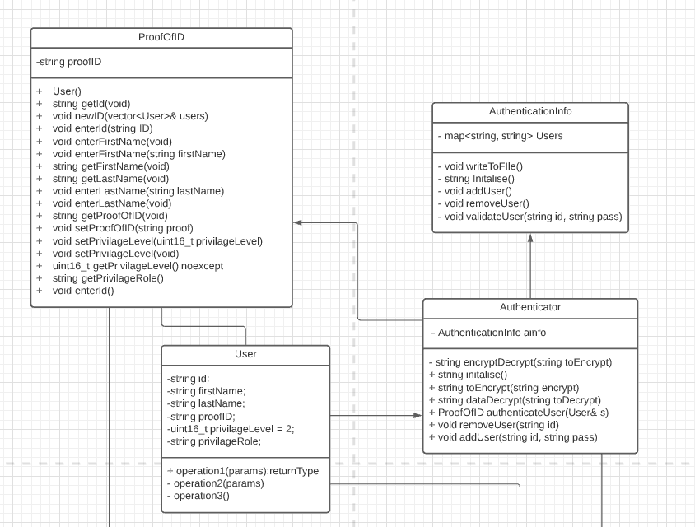

Model View Controller
